**PROJECT DESIGN**

|  |  |
| --- | --- |
| Date | 29-05-2025 |
| Team ID | LTVIP2025TMID28829 |
| Project Name | Medical Inventory Management |
| Maximum Marks | 4 Marks |

**4.3 Solution Architecture**

**Introduction**

The **Solution Architecture** describes how various modules, users, data, and automation features interconnect within the Medical Inventory Management System. The architecture is modular, scalable, and built entirely on the **Salesforce Lightning Platform**, leveraging its standard and custom capabilities.

This section is divided into four sub-sections:

* **4.3.1 Data Model (ER Diagram)**
* **4.3.2 Security Model**
* **4.3.3 Automation and Process Design**

**4.3.1 Data Model (Entity Relationship Diagram)**

**Overview**

The data model is designed using **Custom Objects** and **Standard Objects** in Salesforce to represent the business entities such as inventory items, purchase orders, vendors, and users. The model includes **master-detail** and **lookup relationships** to maintain referential integrity and data granularity.

**Key Entities & Relationships**

| **Object Name** | **Description** |
| --- | --- |
| **Inventory__c** | Stores item details: name, quantity, expiry, category, unit price, department |
| **Vendor__c** | Contains vendor name, contact details, and product types |
| **Purchase_Order__c** | Represents requisitions and approved orders |
| **Stock_Log__c** | Logs stock-in and stock-out activities |
| **Delivery__c** | Links to Purchase Orders and confirms item delivery |
| **User** (Standard) | Salesforce user object, mapped to roles: Manager, Procurement, Admin |

**Relationships:**

* One **Vendor__c** → Many **Purchase_Order__c**
* One **Purchase_Order__c** → Many **Delivery__c**
* One **Inventory__c** → Many **Stock_Log__c**
* One **User** → Many **Purchase_Order__c**

**Flow chart**

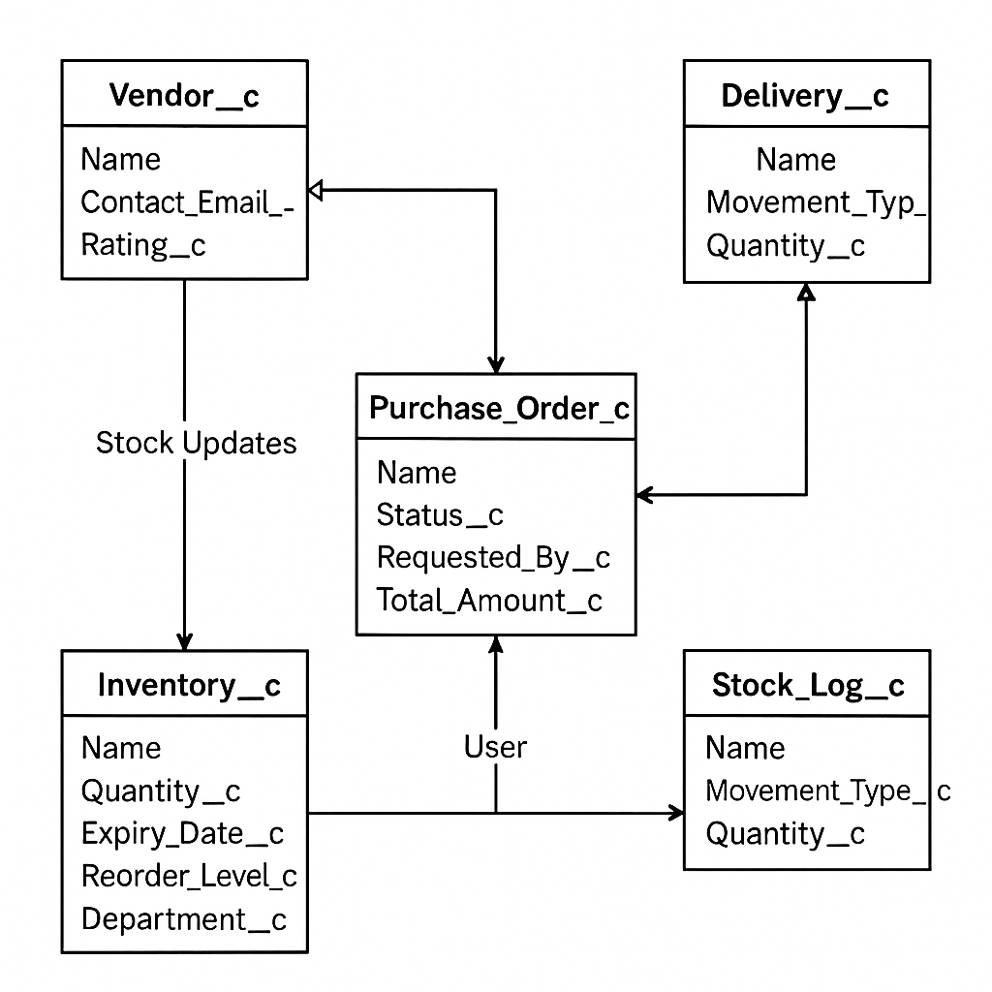

**Entity Relationship Textual Diagram**

**Vendor__c 1---* Purchase_Order__c 1---* Delivery__c**

**|**

**\*---* Inventory__c 1---* Stock_Log__c**

**|**

**\*---1 User**

**Key Fields per Object (Sample)**

* **Inventory__c**: Name, Quantity, Expiry_Date__c, Reorder_Level__c, Department__c
* **Purchase_Order__c**: Status__c, Requested_By__c, Total_Amount__c, Vendor__c
* **Stock_Log__c**: Movement_Type__c (IN/OUT), Quantity__c, Timestamp__c
* **Vendor__c**: Contact_Email__c, Rating__c, Active__c

**4.3.2 Security Model**

**Overview**

To ensure data privacy, access control, and audit-readiness, the system uses **Salesforce’s multilayered security** structure. This includes **Profiles**, **Permission Sets**, **Role Hierarchy**, **Object-Level Security**, and **Field-Level Security**.

**Roles & Access Levels**

| **Role** | **Access Summary** |
| --- | --- |
| **Inventory Manager** | Can manage inventory, request items, and view own stock logs |
| **Procurement Officer** | Can manage purchase orders, vendor info, and approval workflows |
| **Administrator** | Full access to all data, logs, reports, and user management |
| **Auditor** | Read-only access to inventory, logs, and audit reports |

**Security Features Used**

| **Feature** | **Usage** |
| --- | --- |
| **Profiles** | Define base access level per role |
| **Permission Sets** | Grant extra access without changing profiles |
| **Field-Level Security** | Hide sensitive data like pricing or rating from unauthorized users |
| **Org-Wide Defaults (OWD)** | Set default access to private or read-only |
| **Sharing Rules** | Open up visibility for specific records (e.g., department-based sharing) |
| **Audit Trail** | Monitors setup/config changes by users |
| **Field History Tracking** | Logs value changes in key fields (stock, quantity, expiry, PO status) |

**4.3.3 Automation and Process Design**

**Overview**

Automation is central to reducing manual effort, improving accuracy, and enforcing compliance. Salesforce provides **Flow Builder**, **Process Builder**, **Apex Triggers**, and **Scheduled Jobs** to automate actions across the system.

**Key Automated Processes**

| **Process Name** | **Trigger Event** | **Automation Tool** | **Outcome** |
| --- | --- | --- | --- |
| **Low Stock Alert** | Inventory update below threshold | Scheduled Flow | Sends alert to Inventory Manager |
| **Expiry Notifications** | Weekly check for nearing expiry items | Scheduled Apex Job | Notifies Manager with item details |
| **Requisition Approval Flow** | Requisition submission | Approval Process + Flow | Routes request to approver based on department |
| **Auto-PO Generation** | Requisition approved | Record-Triggered Flow | Creates linked Purchase Order record |
| **Delivery Confirmation Update** | Delivery received | Flow + Validation Rule | Updates inventory and closes the PO |
| **Monthly Reports** | First day of each month | Scheduled Flow / Report Job | Email reports to Admin and Management |

**Custom Validations**

| **Validation Rule** | **Purpose** |
| --- | --- |
| Quantity < 0 | Prevents negative stock entries |
| Expiry date < TODAY() | Prevents entry of expired products |
| Duplicate PO for same vendor and item | Prevents duplicate procurement |

**Flow Chart**

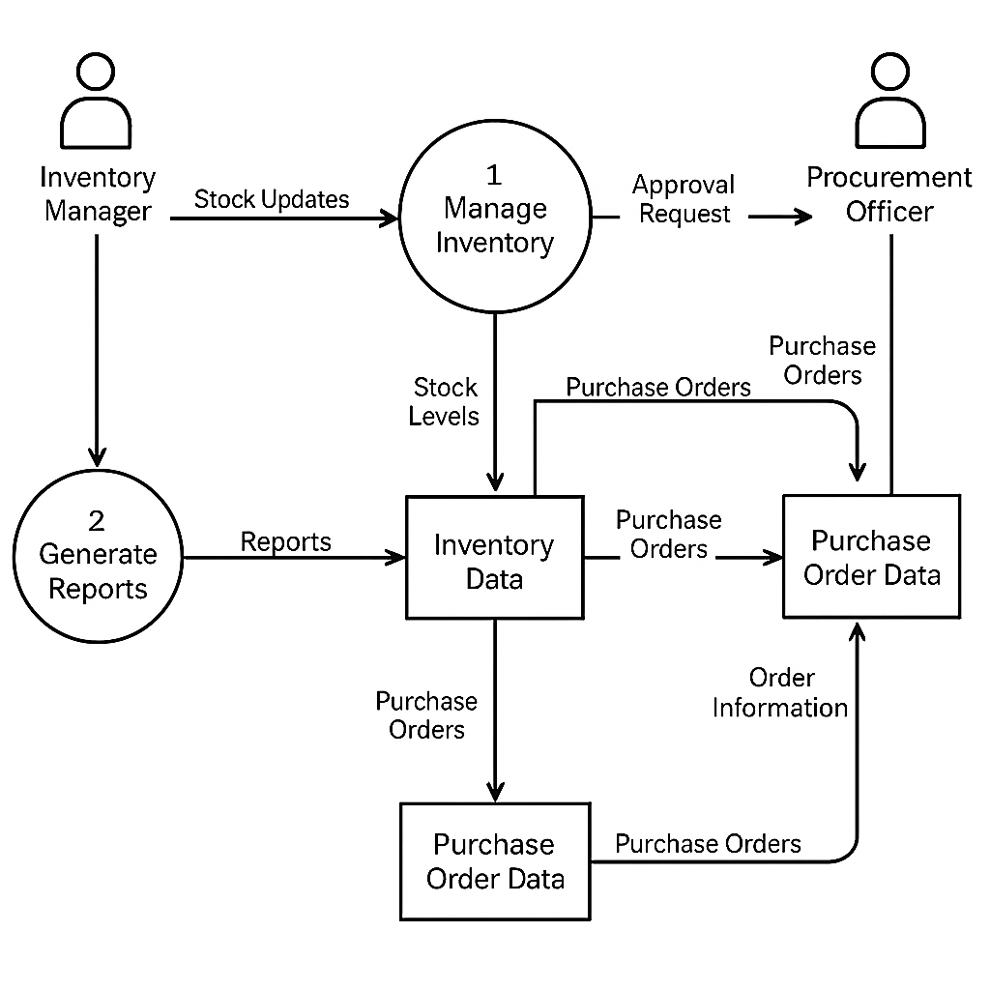

**Conclusion**

The architecture of the Medical Inventory Management System is designed for **modularity, security, and scalability**. The **data model** ensures clean relationships between inventory, vendors, and transactions. The **security model** upholds data access control across roles, while **automation workflows** reduce errors, enhance efficiency, and maintain real-time operations.

The design is Salesforce-native, enabling fast deployment, high configurability, and seamless integration with external systems or hospital extensions in the future..